# Lab 3: Resolution and CSP

## Source code:

student(ram).

pass_exam(ram).

engineer(X):-student(X),pass_exam(X).

enemy(nono).

weapon(X):-missile(X).

american(colonel).

has(nono,missile(X)).

missile(X).

has(colonel,missile(X)).

sell(colonel,nono,X):-missile(X),has(colonel,X).

criminal(X):-american(X),weapon(Z),enemy(Y),sell(X,Y,Z).

digit(0).

digit(1).

digit(2).

digit(3).

digit(4).

digit(5).

digit(6).

digit(7).

digit(8).

digit(9).

different([]).

different([X|R]):-not(member(X,R)),different(R).

solution(L):-digit(S),S>0,digit(E),digit(N),digit(D),digit(M),M>0,digit(O),digit(R),digit(Y),

1000*S+100*E+10*N+D+1000*M+100*O+10*R+E=:=10000*M+1000*O+100*N+10*E+Y,

L=[S,E,N,D,M,O,R,Y],

different(L).

## Output:



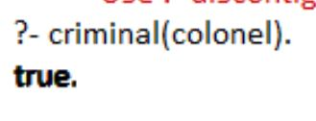

## Conclusion:

Hence in this lab we learnt about implementing resolution and CSP in PROLOG.